Evaluation Documentation

Automated Benchmarking and Evaluation for SDA:

Uncorrelated Track Processing

System Documentation
Rev: [ - ]

Revision History
Rev | Description | Author | Date
- | Initial Release | 2025 AFRL Scholars | 8/13/2025

Table of Contents
File I/O Format 5
EO Observation Dataset 5
TLE Dataset 6
UCT Processor Output 7
Evaluation Output 8
Configuration File Config.py 9
Quick Start Guide 9
Dataset Generation Workflow 10
Time Window Selection 13
Orbital Coverage 15
Simulation of Observations 15
Observations to trackTLE 16
Downsampling 17
True Negatives 18
Decorrelation 18
Evaluation Workflow 18
Frame Conversion 18
TLE to State Vector 19
Orbit Association 19
Propagation 19
State Vector Propagation 19
Covariance Propagation 20
TLE Propagation 20
State Metrics 21
State Metrics for State Vectors 21
State Metrics for TLEs 21
Residual Metrics 22
Binary Classification Metrics 22
Function I/O 23
Dataset Generation Functions 23
Evaluation Functions 1

Definitions
UDL: Unified Data Library, the source of state vector and observation data used in this UCT evaluation product.

UCTP: Uncorrelated Track Processor, the target of evaluation of this product.

TLE: Two-line element set, also referred to as elset

TrackTLE: TLE generated by performing initial orbit determination on a single track of observations. These are used in the benchmark datasets to emulate UCT TLEs

Reference Object: Satellite with known NORAD ID, state vector, TLE, and list of observations publicly available on the UDL that are made a part of a benchmark dataset.

Reference Orbit: State Vector, TLE, a list of observations, and a list of trackTLEs generated from the list of observations that are associated with a Reference Object.

Candidate Orbit: Output generated by the UCTP, defined by a Candidate State Vector and epoch or Candidate TLE, along with a list of observation IDs or trackTLE IDs the UCTP has correlated to that state vector or TLE.

Common Epoch: The epoch in which the Candidate Orbit state vector or TLE is generated.

Propagated Reference: State vector or TLE of Reference Orbit propagated to Common Epoch

Decorrelate: The process in which the state vector and associated observations or TLE and trackTLEs of a Reference Orbit are separated and stripped of NORAD IDs. This makes the observations “Uncorrelated”, which are used to create benchmark datasets that is fed into the UCTP.

Downsample: The process in which some of the observations or trackTLEs associated with a Reference Orbit are strategically removed to simulate certain observation scenarios (e.g, true negative, temporally sparse observations, limited observation window, etc.)

Orbit Association: Before evaluation of the UCTP can take place, each Candidate Orbit must be associated with a Reference Orbit used to generate the benchmark dataset being processed.

Non-associated Candidates: Candidate Orbits that cannot be associated with a Reference Orbit during the Orbit Association procedure.

Non-associated References: Reference Orbits that cannot be associated with a Candidate Orbit during the Orbit Association procedure.

File I/O Format
Create Dataset
MainMVP
Evaluate

EO Observation Dataset
Datasets of observations are given in .json of the form
[
{
“id": "9dabe8c8-2f14-4c63-9a3d-2d810f54e3e2",
"classificationMarking": "U//PR-EXO-OBS",
"obTime": "2025-06-23T19:45:00.225171Z",
"idOnOrbit": "41586",
"idSensor": "EXO7151",
"satNo": 41586,
"taskId": "0",
"origObjectId": "41586",
"origSensorId": "7151",
"uct": false,
"azimuth": 310.5277466167,
"elevation": 53.0376017287,
"range": 36903.668121356,
"ra": 314.8563772662,
"declination": 1.9389976251,
"losUnc": 3.059156,
"senlat": -23.767372,
"senlon": 133.915083,
"senalt": 0.545,
"senx": 5550.769212623,
"seny": -1798.46905472,
"senz": -2568.669765241,
"senvelx": 0.131140029958,
"senvely": 0.405232069216,
"senvelz": -0.000338422495,
"expDuration": 3.63,
"zeroptd": 21.3175960797077,
"netObjSig": 2246.20776035813,
"netObjSigUnc": 69.4214876033058,
"mag": 13.214783,
"magUnc": 0.115642,
"geolat": -1.6910834093,
"geolon": 110.3306078449,
"geoalt": 35785.881573508,
"georange": 36890.154411504,
"solarPhaseAngle": 48.1010647871,
"solarEqPhaseAngle": -42.6143969824,
"solarDecAngle": 24.8443643474,
"shutterDelay": 0,
"rawFileURI":"/Observation/EXO/2025/06/23/19/exo-20250623-195200706-82f6
"source": "EXO",
"dataMode": "REAL",
"createdAt": "2025-06-23T19:53:57.831Z",
"createdBy": "system.exo",
"origNetwork": "OPS1",
"type": "OPTICAL"
},
]

TLE Dataset
Datasets of TLEs are given in .json in the form:
[
{
"idElset": "d688d8a2-81d3-4ceb-8032-c945128b5a41",
"classificationMarking": "U//PR-EXO-ELSETS",
"epoch": "2025-07-02T20:50:51.681027Z",
"meanMotion": 1.0027191749074,
"uct": true,
"eccentricity": 0.00500568344535229,
"inclination": 6.64966633097932,
"raan": 15.1408773270208,
"argOfPerigee": 49.8819406821671,
"meanAnomaly": 274.278737836812,
"bStar": 0,
"meanMotionDot": 0,
"meanMotionDDot": 0,
"semiMajorAxis": 42164.6968714354,
"period": 1436.09500649369,
"apogee": 42375.759996543,
"perigee": 41953.6337463278,
"origObjectId": "901017267",
"line1": "1 99999U 00000A 25183.86865372 +.00000000 +00000+0 +00000+0 2 99998",
"line2": "2 99999 6.6497 15.1409 0050057 49.8819 274.2787 01.00271917000000",
"createdAt": "2025-07-02T21:12:31.405Z",
"createdBy": "system.exo",
"source": "EXO",
"dataMode": "REAL",
"ephemType": 2,
"origNetwork": "OPS1"
},
]

Benchmark datasets are fed directly into the UCT processor to be evaluated. Different datasets consisting of either EO Observations or TLEs are generated depending on what type of input the UCTP under evaluation requires.

UCT Processor Output
If the UCTP outputs state vectors, the output is expected in .json, containing at least the following data labels:
[
{
“idStateVector”: “unique alphanumeric string”,
“sourcedData”: [“observation ID”, ”observation ID”, ….. ],
“sourcedDataTypes”: [“EO” , ”EO”, “EO” , …..]
“epoch”: “yyyy-mm-ddThh:mm:ss.ssssssZ”
“xpos”: [float in units of km],
“ypos”:
“zpos”:
“xvel”: [float in units of km/s],
“yvel”:
“zvel”:
“referenceFrame”: “J2000”, (or other frame)
“covReferenceFrame”: “J2000”,
“cov”: [list of 21 values giving lower triangular elements of covariance matrix],
}
]

If the UCTP outputs TLEs, the output is expected in .json, containing at least the following data labels
[
{
"idElset": "57887e64-85fd-40f5-a65d-cfb8acb99ec1",
“epoch”: “yyyy-mm-ddThh:mm:ss.ssssssZ”
"meanMotion": 12.872373104667524,
"eccentricity": 0.0005349967465871388,
"inclination": 62.389226664716325,
"raan": 109.92305596213806,
"argOfPerigee": 191.58062946428743,
"meanAnomaly": 135.25979362124275,
"bStar": 4.9999999999999996e-05,
"meanMotionDot": 0,
"meanMotionDDot": 0,
"semiMajorAxis": 7690.658471099986,
"period": 111.86748459597212,
"apogee": 7694.7729483611365,
"perigee": 7686.5439938388345,
"line1": "1 99999U 00000A 25168.40556060 +.00000073 +00000+0 +50000-4 0 99990",
"line2": "2 99999 62.3892 109.9230 0005350 191.5806 135.2597 12.87237310000000",
“sourcedData”: [“idElset”, ”idElset”, ….. ],
“sourcedDataTypes”: [“ELSET” , ”ELSET”, “ELSET” , …..]
}
]

“sourcedData” is a list of unique alphanumeric strings corresponding to the “id” or “idElset” data label for the observations or TLEs in the benchmark dataset that the UCT processor has correlated to the given state vector or TLE. “epoch” is the time epoch at which the given state vector or TLE is valid.

Evaluation Output
An evaluation report will be generated and saved as a PDF file at the end of the evaluation algorithm. It contains tables that show Associated Orbits, Binary Metrics, and State results. It also contains graphs showing the residuals of both the Candidate and Reference Orbits. At the top of the PDF, there is the Dataset code so the UCTP can tell exactly what kind of data was used in their testing. The goal of this PDF is to give the UCTP a way to tell how their processor performed at a glance.

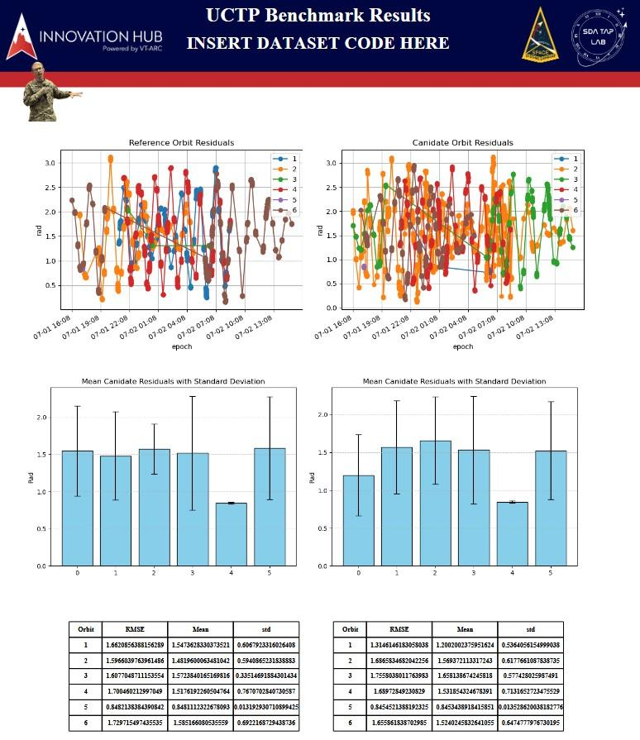

Configuration File Config.py
The configuration file contains variables and parameters used elsewhere in the code base. Most of the parameters are related to the window scoring function, such as what is considered low orbital coverage for each orbital regime, cutoffs for low and high observation counts, and percentages to include in the dataset if a certain characteristic is desired to be ‘high’, ‘standard’, or ‘low.’ Also in the configuration file are default coefficients for atmospheric drag and solar radiation pressure used in the propagator force model, as well as the default number of sample points used in the Monte Carlo simulation to propagate covariance. Also included are default noise parameters for observation simulation.

Quick Start Guide
Save UDL Base64 API Token as an environment variable $env:ULD_TOKEN
Select dataset code representing the desired data
Run Create_Dataset_New.py
User will be prompted to select desired data
Dataset will be saved as src/data/output_dataset.json
MainMVP.py
Evaluation.py
generationDriver.py

Dataset Generation Workflow
Datasets will be generated according to the desired characteristics input by the end user. The characteristics of the dataset will be encoded in a 16-character string, as shown below.
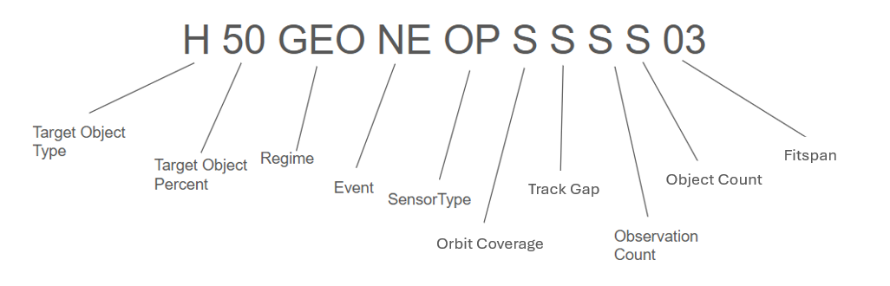
Target Object Types
High Area to Mass Ratio (HAMR) | Close Objects | Close Apparent Objects | Unspecified | Calibration
> 1 m^2/kg | distance<X km  velocity<X m/s | Angles within:  X ° | Datasets unconstrained by object types | Well-tracked objects only
H | C | A | U | N

Note: Close objects and close apparent objects have not yet been implemented; these values are arbitrary until more research is conducted.

Potential Calibration/Well-tracked Satellites (NORAD ID):
1328, 5398, 7646, 8820, 16908, 19751, 20026, 22195, 22314, 22824, 23613, 24876, 25544, 26360, 27566, 27944, 32711, 36508, 39070, 39086, 39504, 40730, 41240, 41335, 42915, 43476, 43477, 43873, 46826, 48859

Target Object Percent
Selecting Unspecified (UN) will allow the dataset generator to select a time window with any natural distribution of objects, so long as the target object type is contained in any percentage within the dataset. For target object type unspecified (U), this must be unspecified (UN) as well.
50% Target objects | 10% Target objects | 01% target objects | Unspecified
50 | 10 | 01 | UN

Orbital Regime
Semi-major axis a measured in km (note that LEO corresponds to mean altitude <2000 km)
Low Earth Orbit (LEO) |  | Middle Earth Orbit (MEO) |  | Geosynchronous Orbit (GEO) |  | Highly Elliptical Orbit (HEO) |  | All Regimes
a ≤ 8378 km |  | 8378 < a < 42164 km |  | a ≥ 42164 km |  | Eccentricity e ≥ 0.7
LEO |  | MEO |  | GEO |  | HEO |  | ALL
Combination of 2 Regimes |  |  |  |  | Combination of 3 Regimes
Designator is the first letter of the two regimes in the order above, followed by an “O”  EX: LEO/MEO→ “LMO” |  |  |  |  | Designator is the first initials of all categories in the above order.  EX: LEO/MEO/GEO → “LMG”

Event
Any particular type of event to be included in the dataset The dataset will contain at least one of the selected types of events. Only one type of event selection is allowed, as each event constrains the possible time windows in which the dataset can be generated. Since the UDL does not contain these events directly, we are relying on the ML Labelling Team to feed us the NORAD IDs and Observation times corresponding to these events. As of the writing of this report, the ML Model is not operating.
Maneuver Between Obs | Breakup | Long Duration/Low Thrust | No Events
MB | BU | LL | NE

Sensor Type
Optical | Radar | Radio Frequency (RF) | Fusion of all sensor types | Optical/RF | Optical/Radar | Radar/RF
OP | RA | RF | FU | OR | RO | RR

Orbit Coverage
Calculation of orbit coverage is defined in the section below. Definition of ‘Low’ coverage varies for each orbital regime (e.g. LEO, MEO, GEO). There is also a minimum coverage below which objects will not be included in the dataset.
>90% of objects have low orbital coverage | 40-60% of objects have low orbital coverage | <10% of objects have low orbital coverage
A | S | N

LEO (Low <0.0213% covered)
MEO (Low <0.0449% covered)
GEO (Low <41.656% covered)

Track Gap
Track Gap is defined as the longest duration of time between observations of an object. A ‘long’ track gap is defined as a duration exceeding two (2) orbital periods of the object. Orbital Regime and Fitspan take precedence over track gap, so it may not be possible to achieve the desired track gap given the desired regime and fitspan (e.g. you cannot have a 2-period track gap for GEO objects with a 1-day fitspan).
>90% of objects have a long track gap | 40-60% of objects have a long track gap | <10% of objects have a long track gap
A | S | N

Observation Count
Total number of unique observations per object per 3-day timespan. ‘Low’ observation count is less than 50, ‘standard’ observation count is between 50-150. Objects with greater than 150 observations will either not be used or will be downsampled to a ‘standard’ observation count. https://www.researchgate.net/publication/291010221_Minimum_Number_of_Observation_Points_for_LEO_Satellite_Orbit_Estimation_by_OWL_Network )
>90% of objects have low observation count | 40-60% of objects have low observation count | <10% of objects have low observation count
A | S | N

Object Count
Total number of objects to be included in the benchmark dataset (+/- 2).
High number of objects:  80 +/- 2 | Standard Number of Objects:  40 +/- 2 | Low number of objects:  10 +/- 2
H | S | L

Fitspan
Duration of time the dataset will span. Fitspan can be input as a 2-character integer number between 1-14 (e.g., 01, 07, 14, etc.)

Time Window Selection
The first step in creating a dataset is identifying an ideal time window. The optimal time window is one for which all user-selected criteria are met, with no downsampling or simulation required. This is referred to as a Tier-1 time window. A Tier-2 time window is one for which downsampling is necessary, but no simulation is needed. Tier-3 is when simulation of observations for objects that already exist in the dataset is required to achieve the desired orbital coverage and/or number of observations. Tier-4 is when simulation of new reference objects is required in order to achieve the desired number of target objects in a dataset. Downsampling may or may not be required for Tier-3 and Tier-4, and does not affect the tier. Tier-5 occurs when the selected criteria cannot possibly be met.
The window selection algorithm is outlined in the flow chart below.

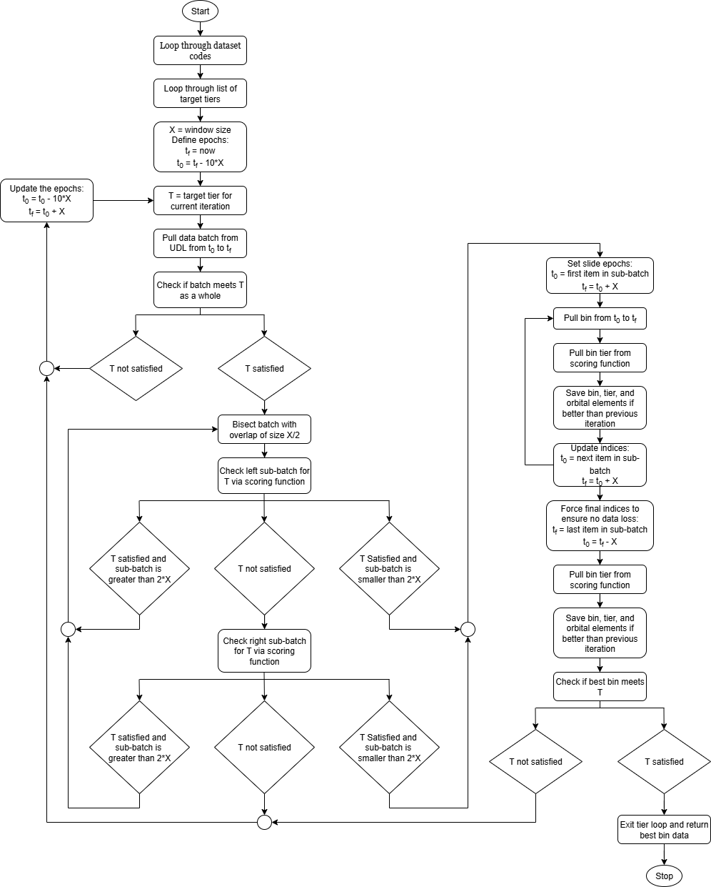

Orbital Coverage
Typically, orbital coverage is given in terms of angular distance covered by observation tracks. However, this definition is muddled in real data that lacks a well-defined start or end of a track. The following coverage definition is used instead to account for the discrete and unclear nature of real data, while still heavily rewarding spread-out observations and avoiding periapsis/apoapsis bias due to eccentricity.
- Fit all observations to their nearest approach of the reference orbit. This “locks” the observations onto the orbital path, countering measurement noise.
- Draw a projection from the geometric center of the orbit through each fitted observation onto the circle that circumscribes the orbital ellipse. This removes periapsis/apoapsis bias.
- Generate a convex polygon whose vertices are the projected points and take its area.
- The orbital coverage is the area of the polygon normalized by the circumscribed circle’s area.
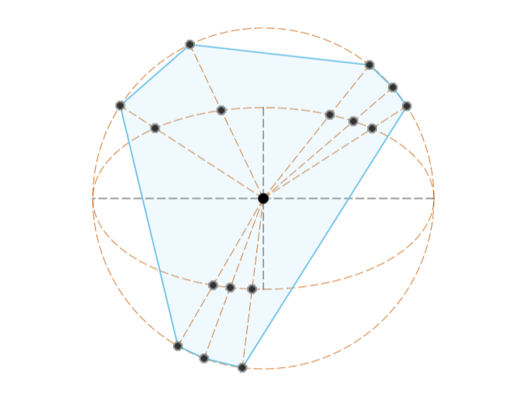

Simulation of Observations
It is always preferred to use real data when sufficient observational data is available. In cases where sufficient observational data is not available, data will need to be simulated. When simulated data is present, it will be clearly identified in the dataset label as well as the observation metadata (i.e. "dataMode": "SIMULATED"). There are 2 specific subclasses of data simulation. Class one is when it is necessary to simulate specific observations for reference objects that already exist in the dataset to achieve a desired orbital coverage or a certain number of observations. Class two is when it is necessary to simulate an entirely new reference object because a sufficient number of reference objects do not exist in the dataset. The process by which data is simulated is as follows.

- A list of the most common observatories from which the real data is sourced and maintained. An observatory from this list will be randomly selected for each observation to simulate the observation from.
- A list of observation epochs required (to achieve the desired orbital coverage or track gap) is generated, and the reference orbit is propagated to each observation epoch.
- Uncorrelated Gaussian random variables are added to each position component of the propagated state vector.
- The position is then converted into a right ascension and declination measurement. Uncorrelated Gaussian random variables are added to each of the right ascension and declination.
- The right ascension and declination are then converted into an azimuth and elevation measurement using the location of the previously selected observatory

Observations to trackTLE
Some UCTPs take Uncorrelated TLEs as input. These are TLEs formed from the observations collected from a single observatory. The TLEs on the UDL are too accurate to be used as input for the UCTPs, because the TLEs in the UDL are refined by several observation passes from multiple observatories. Thus, an algorithm has been developed to take raw observations and create the track TLEs that are more similar to what the uncorrelated TLEs that UCTPS would see.
The observations in the time window are first separated by the observatory they originate. Using a Modified Gauss Method popularized in Vallado’s “Fundamentals of Astrodynamics and Applications”, the code generates as many valid states from each observational pass. It does this by trying all valid permutations of triplet observations and only keeping those that give sensible results. These state vectors are refined using the batch least squares filter built into Orekit’s BatchLSEstimator class. The initial state vector is converted into a TLE, and the batch filter uses the rest of the states as pseudo-observations and an SGP4 propagator to converge on a solution. The final TLE output from the batch least squares filter is the trackTLE for the track of observations at the observatory.

https://www.orekit.org/static/apidocs/org/orekit/estimation/leastsquares/BatchLSEstimator.html
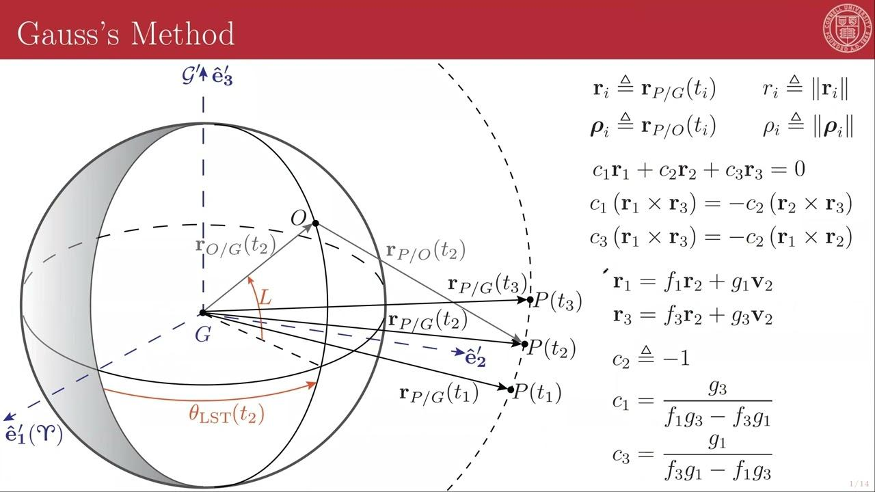

Downsampling
Should the observational data be of higher quality than desired, statistical downsampling will be performed to obtain the desired dataset characteristics. The presence and quantity of downsampling performed will be identified in the dataset metadata. Three (3) metrics are utilized in downsampling, each corresponding to a user-defined specification:
- Orbit Coverage
- Track gap
- Number of observations

Downsampling is performed sequentially in the order described above. Simulated satellites, satellites containing simulated data, and “true negative” satellites containing 2 or fewer observations are not considered for downsampling. The algorithms used are as follows:
- Orbital Coverage: Satellites with the lowest existing orbit coverage (above the threshold) are chosen first. Observations are chosen by determining which will remove the largest coverage area, from among those with a neighbor within 0.1 periods temporally. Should this result in an inability to reduce coverage to the desired amount, the time restriction is dropped, and downsampling is recomputed.
- Track gap: Satellites with the highest track gap (below the threshold) are chosen first. Observations are chosen via a sliding window algorithm that determines the window of desired temporal size, which contains the minimum number of observations, and all observations within that window are removed.
- Number of observations: Satellites with the lowest observation count (above the threshold) are chosen first. Observations are binned into 10 groups based on time quantiles, and an equal number is removed randomly from each bin.

True Negatives
Datasets generated will include some percentage of true negatives, observations that do not correlate with any of the reference objects or observations in the dataset. To guarantee that the observations do not correlate with anything in the dataset, 2 observations corresponding to a real satellite that is not part of the dataset will be used. Since it's not possible to do IOD on 2 optical observations, there is no way for an orbit to be associated with them. True negative datapoints will be added after all of the other data manipulation (time-window selection, downsampling, simulation) is complete.

Decorrelation
After all data manipulation (time-window selection, downsampling, simulation) is complete, the dataset will be decorrelated. Each observation will have its corresponding satellite ID removed from the observation, and the observations will be dissociated from the reference orbits. However, observations will still be grouped by their observational passes. I.E, all observations taken from the same observatory over a single pass will be assigned the same track number. This will leave a list of observations that will be output to the user to be fed into the UCTP under test. Additionally, an ‘answer key’ will be created that has a list of reference objects in the dataset, and associated with each reference object will be a list of observation IDs that correlate to that reference object. This answer key will be withheld from the user and used in conjunction with the UCTP output in the evaluation workflow.

Evaluation Workflow

Frame Conversion
Reference frame for each Reference Orbit state vector and covariance is specified as either J2000, EFG/TDR, ECR/ECEF, TEME, ITRF, or GCRF in the UDL. Each Candidate Orbit state vector and covariance frame is specified as one of the above by the UCTP output. Every state vector (both reference and candidate) that is given in a frame that is not J2000 is converted to the J2000 frame using the getTransformTo method of the Orekit Frame class. The J2000 frame all state vectors are converted into is referred to in Orekit as EME2000. <https://www.orekit.org/static/apidocs/org/orekit/frames/Frame.html>
The reference frame of the covariance (for both reference and candidate) is transformed using the changeCovarianceFrame method of Orekit StateCovariance class. <https://www.orekit.org/static/apidocs/org/orekit/propagation/StateCovariance.html>
TLEs do not require a change of reference frame since the TLE format is standardized

TLE to State Vector
Conversions from TLEs to State Vectors, when necessary, are done using the Orekit TLEPropagator class. A TLEPropagator object is instantiated with the TLE to be converted using the selectExtrapolator method, followed by using the getPVCoordinates method without doing any propagation.
<https://www.orekit.org/static/apidocs/org/orekit/propagation/analytical/tle/TLEPropagator.html>

Orbit Association
The evaluation framework will associate Candidate Orbits with Reference Orbits by solving an optimal assignment problem using a modified Jonker-Volgenant algorithm with no initialization. Assignment is implemented using the linear_sum_assignment function of the Python library scipy.optimize <https://docs.scipy.org/doc/scipy/reference/generated/scipy.optimize.linear_sum_assignment.html>.
The assignment cost matrix is constructed as follows:
- For every permutation of Reference Orbit/Candidate Orbit pair, the Reference Orbit is propagated to the Common Epoch using Orekit (see Propagation).
- If the Reference Orbits and Candidate Orbits are given in TLEs, they are both converted to 6D state vectors (see TLE to State Vector)
- The 6D vector difference between the Propagated Reference and the Candidate Orbit is taken.
- The L2 norm of that difference vector is assigned as the cost.
In the case of an equal number of Reference Orbits and Candidate Orbits, this shall obtain a 1:1 mapping between them. In the case of a greater number of Reference Orbits, a 1:1 assignment is performed, and any outstanding Reference Orbits are marked as Non-associated References. In the case of a greater number of Candidate Orbits, a 1:1 assignment is performed, and any outstanding candidates are marked as Non-associated Candidates.

Propagation

State Vector Propagation
State vectors are propagated in Orekit using the numerical integrator DormandPrince853 with a minimum step size of 0.0001s, maximum step size of 1000s, relative tolerance of 10E-14, and absolute tolerance of 10E-12. The Earth's gravity is modeled according to the Holmes Featherstone Attraction Model, including spherical harmonics to degree and order 120. The gravitational influence of the Sun and Moon are included as point masses. Atmospheric drag is modeled using NRLMSISE-00 atmospheric density model and CSSI Space Weather data, publicly available from Orekit. Atmospheric drag is modeled as isotropic, according to the average cross-sectional area available from the European Space Agency (ESA) database and the default drag coefficient. Solar radiation pressure is modeled isotropically according to the same average cross-sectional area and default solar radiation pressure coefficient. The solar radiation pressure model accounts for the umbra and penumbra shadow regions of the Earth. Also needed for accurate propagation is the satellite mass, which is obtained from the ESA database along with the cross-sectional area.
<https://www.orekit.org/>
<https://www.hipparchus.org/apidocs/org/hipparchus/ode/nonstiff/DormandPrince853Integrator.html>
<https://www.orekit.org/static/apidocs/org/orekit/forces/gravity/HolmesFeatherstoneAttractionModel.html>
<https://www.orekit.org/static/apidocs/org/orekit/models/earth/atmosphere/NRLMSISE00.html>
<https://www.orekit.org/static/apidocs/org/orekit/models/earth/atmosphere/data/CssiSpaceWeatherData.html>
<https://www.orekit.org/static/apidocs/org/orekit/forces/radiation/SolarRadiationPressure.html>

Covariance Propagation
The covariance of the Reference Orbit is propagated in Orekit using the same force model as described above. A Monte Carlo simulation is performed, where N (passed as a parameter to the propagation function, default 100 ) datapoints are sampled from the multivariate normal distribution defined by the mean and covariance of the Reference Orbit. These sample points are then propagated from the initial epoch to the final epoch, and the covariance of the resulting sample distribution is calculated. Since the initial points are randomly sampled from the initial distribution, there is a nonzero probability that the sampled points would be propagated to orbit within the ellipsoid of the Earth. These points are discarded, and the covariance of the posterior distribution is estimated from the remainder of the initial sample points.

TLE Propagation
TLEs are propagated in Orekit using the TLEPropagator class, which uses the SGP4 or SDP4 force model, which is selected internally when the propagate method is called according to NORAD recommendations. ‘Near Earth’ objects are defined by NORAD as having an orbital period less than 225 minutes, and use the SGP4 model. ‘Deep-Space’ objects are defined by NORAD as having an orbital period greater than or equal to 225 minutes, and use the SDP4 model.
<https://www.orekit.org/static/apidocs/org/orekit/propagation/analytical/tle/TLEPropagator.html>

State Metrics
State metrics refer to comparing the Candidate Orbit to the Reference Orbit (either as state vectors or TLEs) to determine the accuracy of the orbit estimation.

State Metrics for State Vectors
For a given Reference Orbit/Candidate Orbit pair, the Reference Orbit state vector and covariance are propagated to the Common Epoch using Orekit (see State Vector Propagation). The following metrics are then computed for each pair:
- L2 Norm of the vector difference between reference and candidate, for position, velocity, and total 6D states.
- Bias of the candidate with respect to the reference for each position and velocity dimension.
- Mahalanobis Distance: between the reference and candidate, defined as with the combined covariance matrix and state vectors X.
- Mahalanobis Distance p-score: computed with respect to the chi-squared distribution with 6 degrees of freedom as . This p-score is a percentage confidence that the reference and candidate orbits are the same orbit, given their covariance. (ranges from 0.0 to 1.0 with 1.0 being full confidence)
- Normalized Estimation Error Squared: between the reference and candidate, defined as with state vectors X and candidate covariance matrix.
- NEES p-score: computed with respect to the chi-squared distribution with 6 degrees of freedom as . This p-score is a measure of the UCTP’s confidence. A value below 0.5 indicates an overconfident processor, while a value above 0.5 indicates excessive covariance/underconfidence.

State Metrics for TLEs
For a given Reference TLE/Candidate TLE pair, the Reference TLE is propagated to the Common Epoch using Orekit’s TLE propagator (see TLE Propagation). Both TLEs are then converted to state vectors using Orekit’s built-in converter (see TLE to State Vector) to generate L2 Norm and bias metrics from State Metrics for State Vectors. The other metrics are not computed due to TLEs lacking covariance and uncertainty.

Residual Metrics
Residual Metrics determine the unit-sphere projected great circle residuals between the actual observations or trackTLEs and the estimated observations or trackTLEs determined by propagating the Candidate Orbit to the epoch of each observation or trackTLE. Use of this function is split into two categories:
- Comparison of the Reference Orbit observations or trackTLEs with the Candidate Orbit. This gives a measure of how accurate a Candidate Orbit is to the truth.
- Comparison of the Candidate Orbit observations or trackTLEs with the Candidate Orbit. This gives a measure of how precise a Candidate Orbit is to its own correlation.
For each category, the root mean squared (RMS) of the error between the actual observation or trackTLE and the estimated observation or trackTLE generated from propagation of the Candidate Orbit.

Binary Classification Metrics
The binary classification function will classify each observation or TrackTLE in the benchmark dataset as either True Positive, True Negative, False Positive, or False Negative, as defined below.
- True Positive (TP): Observation or TrackTLE belongs to both the Candidate Orbit and the Reference Orbit to which it has been associated
- True Negative (TN): Observation or TrackTLE does not belong to any Candidate Orbit or Reference Orbit
- False Positive (FP): Observation or TrackTLE belongs to a Candidate Orbit but not the Reference Orbit to which it has been associated
- False Negative (FN): Observation or TrackTLE does not belong to a Candidate Orbit but does belong to the Reference Orbit to which it has been associated
From the previous classifications, secondary metrics are calculated as defined below:
- Accuracy: (TP + TN) / (TP + FP + TN + FN)
- Recall/Sensitivity: TP/(TP+FN)
- Balanced Accuracy: (½) [TP/(TP+FN) + TN/(TN+FP)]
- Cohen’s Kappa Coefficient: 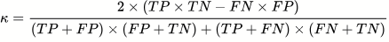
- Matthews Correlation Coefficient: [(TP)(TN)-(FP)(FN)]/sqrt[(TP+FP)(TP+FN)(TN+FP)(TN+FN)]
- Positive Predictive Value/Precision: TP/(TP+FP)
- F1 Score: (2TP)/(2TP+FN+TN)
- Specificity: TN/(TN+FP)

Function I/O
Function definitions are listed in the order in which they first appear within the workflow:

Dataset Generation Functions
windowTools.createDatasetCodeGUI:
def createDatasetCodeGUI():
Launches a GUI for editing dataset parameters using customtkinter.

Functionality:
- Presents categorized dataset parameters as checkboxes or entry fields.
- Allows users to modify selections for target objects, distributions, regimes, events, sensors, etc.
- Validates inputs and saves updates to a pandas DataFrame.
- Shows success message and automatically closes the GUI after saving.

Inputs:
- None (default dataset parameters are hardcoded inside the function).

Outputs:
- Returns a pandas DataFrame with columns ["Parameter", "Value"] reflecting user selections.

windowTools.codeGenerator
def codeGenerator(parameters):
Generate a list of dataset codes representing all combinations of selected parameters.

Input:
parameters (DataFrame): A 10-row DataFrame where each row corresponds to a parameter category.
- Each 'Value' field should be a dictionary or list representing selected values.
- Boolean dictionaries indicate selected options (True/False for each key).
- Lists are treated as directly selected values (e.g., ['1', '2']).

Output:
List[DatasetCode]: A list of DatasetCode objects, each created by concatenating
one value from each selected parameter category.

apIntegration.generateDataset:
def generateDataset(UDL_token, ESA_token, satIDs,timeframe,timeunit,dt=0.1,max_datapoints=0,endTime='now'):
Generates a benchmark dataset given satellites and various parameters.

Args:
UDL_token (string): Your UDL Base64 login token. If you don't have one, use UDLTokenGen or the Utilities page of the UDL Help site.
ESA_token (string): Your ESA Discosweb access token. If you don't have one, generate one at https://discosweb.esoc.esa.int/tokens.
satIDs (numpy Array): List of satellites you wish to pull obs from.
timeframe (int): Timespan of sweep.
timeunit (string): Unit of timeframe.
dt (float): Rate limit for UDL calls in sec. Please check EULA or contact Bluestack before making this very small. Defaults to 0.1.
max_datapoints (int): If > 0, limit of obs data return per satellite, returning newest obs. Defaults to 0 (disabled), max 10000.
endTime (datetime.datetime): Sets the end time of the data timespan. Defaults to 'now' which sets end to current time.

Returns:
Pandas DataFrame: A dataset of "uct" observations.
Pandas DataFrame: The truth observations, matched using "id" field.
Pandas DataFrame: The truth state vectors of requested satellites.
Pandas DataFrame: The truth TLEs of requested satellites.
Array (int): All satellites that were actually obtained.
Dict: Various runtime data.

Raises:
TypeError: If input types are incorrect.
HTTPError/ClientResponseError: If a query fails.

apiIntegration.asyncUDLBatchQuery:
def asyncUDLBatchQuery(token, service, params_list, dt=0.1, count=False, history=False):
Performs an async batch of UDL searchs using the given parameters.

Args:
token (string): Your UDL Base64 login token. If you don't have one, use UDLTokenGen or the Utilities page of the UDL Help site.
service (string): The service requested from UDL.
params_list (list): A list of params sent into UDLQuery. Read that documentation for more information.
dt (float): Rate limit for UDL calls in seconds. Defaults to 1 second.
count (bool): If True, returns a count query instead of a data one. Defaults to False.
history (bool): If True, uses the History Rest API instead of the standard Rest API. Defaults to False.

Returns:
Pandas DataFrame: The results of your queries concated (count = False)
int: The sum of all query counts (count = True)

Raises:
TypeError: If input types are incorrect.
ClientResponseError: If a query fails.

apiIntegration.discoswebQuery:
def discoswebQuery(token, params, data='objects', version=2):
Performs an ESA Discosweb search using the given parameters.

Args:
token (string): Your ESA Discosweb access token. If you don't have one, generate one at https://discosweb.esoc.esa.int/tokens.
params (dict): A string of search parameters in the form "searchTerm1&searchTerm2". Please read https://discosweb.esoc.esa.int/apidocs/v2 for formatting.
data (string): The requested data type from Discosweb. Defaults to "objects".
version (int): The requested Discosweb API version. Defaults to version 2.

Returns:
Pandas DataFrame: The results of your query.

Raises:
TypeError: If input types are incorrect.
HTTPError: If login or query fails.

unitConversion:
def unitConversion(ref_orbit):
Converts the reference orbit and covariance data from various coordinate frames
(TEME, GCRF, ITRF, ECEF, TDR) provided by the UDL API
to J2000 coordinates .

input:
ref_orbit: pd.DataFrame containing the reference orbit data with columns:

output:
df: pd.DataFrame with converted coordinates and covariance matrices in J2000 frame

windowCheckEdit.batchPull:

basicScoringFunction:
def basicScoring(datasetCode, allObs, satData):
Score satellite observations based on orbital coverage, observation count, and observation timing.

Parameters:
- allObs (pd.DataFrame): Observation records with satellite numbers and timestamps.
- satData (pd.DataFrame): Satellite metadata including TLE lines and HAMR classification.
- dataset_partnumber (str): Encoded string defining target dataset characteristics.

Returns:
- true_flag (str): The tier flag (T1, T2, T3, T4) indicating needed actions for dataset generation.
- orbElems (dict): Dictionary of orbital elements and derived metrics keyed by satellite number.

dataManipulation.binTracks:
def binTracks(ref_obs, ref_sv, cutoff=90):
Bins a set of observations into pseudo "tracks" for TLE generation.

Args:
ref_obs (Pandas DataFrame): Dataframe of observations to bin.
ref_sv (Pandas DataFrame): Associated list of reference orbital state vectors.
cutoff (int): Time gap to constitute a "track", in minutes. Defaults to 90.

Returns:
List: List of binned Dataframes in (satNo, period in sec, df) tuple pairs.
Array: Track metrics - [total, kept, discarded, invalid]

dataManipulation.downsampleData:
def downsampleData(ref_obs, dataset, sat_params, orbit_coverage, track_length, obs_count, bins=10, rand=None):
Does best downsampling of a observation dataset given specified parameters.

Args:
ref_obs (Pandas DataFrame): Dataframe of reference observations.
dataset (Pandas DataFrame): Associated dataframe of decorrelated observations.
sat_params (Dict): Associated super-dict of orbital elements in the following form:
sat_params = {
satNo: {
"Semi-Major Axis": a,
"Eccentricity": e,
"Inclination": i,
"RAAN": RAAN,
"Argument of Perigee": arg_perigee,
"Mean Anomaly": M,
"Period": P,
"Number of Obs": #Obs,
"Orbital Coverage": %Coverage,
"Max Track Gap": T/P
},
satNo: {...},
satNo: {...},
...
}
All values are in km, degrees, and seconds as appropriate.
orbit_coverage (Dict): Dictionary of coverage downsample requests in the following form:
- 'sats': List of sat IDs (leave as None if all requested)
- 'p_bounds': Tuple of lower and upper percentages in decimal
- 'p_coverage': Requested max coverage in decimal
track_length (Dict): Dictionary of track downsample requests in the following form:
- 'sats': List of sat IDs (leave as None if all requested)
- 'p_bounds': Tuple of lower and upper percentages in decimal
- 'p_track': Requested track length in multiples of period
obs_count (Dict): Dictionary of observation downsample requests in the following form:
- 'sats': List of sat IDs (leave as None if all requested)
- 'p_bounds': Tuple of lower and upper percentages in decimal
- 'obs_max': Requested maximum obs count
bins (int): Number of bins for time downsampling. Defaults to 10.
rand (float): Random seed for reproducability. Defaults to None.

Returns:
ref_obs, dataset: Downsampled DataFrames.
p_reached: Tuple of (coverage %, gap %, obs_count %) reached.

simulateObservations.simulateObs:
def simulateObs(input1, input2, timespan, sensorsDataFrame, positionNoise=config.positionNoise, angularNoise=config.angularNoise, step=10.0, satelliteParameters=[99999, 0, 0]):
Simulate RA/Dec observations from TLE using Orekit-generated ephemeris.

Parameters:
input1: state vector (6x1 np.array) OR TLE line 1 (string)
input2: Epoch of state vector (datetime) OR TLE line 2 (string)
timespan (float OR datetime list): Duration in seconds from to simulate obs for OR list of epochs to simulate observations at.
sensorsDataFrame (pd.DataFrame): DataFrame containing sensor information with columns ['idSensor', 'senlat', 'senlon', 'senalt', 'sensorLikelihood'].
positionNoise (float): Standard deviation of the position noise in meters (default is 0).
angularNoise (float): Standard deviation of the angular noise in degrees (default is 1/3600 or 1 arcsecond).
step (float): Sampling interval in seconds (default is 10s).
satelliteParameters (list): List of satellite parameters [satNo, mass, cross-sectional area] (default is [99999, 0, 0]), only used for state vector input.

Returns:
pandas dataframe in UDL EOobs schema:

TLEGeneration:
def TLEGeneration(ref_obs, ref_sv):
Takes observations and states and makes crude TLEs out of them

Parameters:
ref_obs dataframe containing all the observations
ref_sv dataframe containing all the state vectors

Returns:
df_output dataframe containing all TLEs

apiIntegration.saveDataset:
def saveDataset(ref_obs,obs_data,ref_track,track_data,ref_sv,ref_elset,output_path):
Saves obtained data to a json file in the format:
output_json: {
'dataset_obs': Dataframe
'dataset_elset': Dataframe
'reference': Dataframe containing:
groupedObs
groupedObsIds
groupedElsets
groupedElsetIds
}

Args:
ref_obs (Pandas DataFrame): Dataframe of "truth" observations.
obs_data (Pandas DataFrame): Dataframe of decorrelated observations.
ref_track (Pandas DataFrame): Dataframe of "truth" track TLEs.
track_data (Pandas DataFrame): Dataframe of decorrelated track TLEs.
ref_sv (Pandas DataFrame): Dataframe of satellite state vector data.
ref_elset (Pandas DataFrame): Dataframe of satellite TLE data.
output_path (string): Relative save path for the file.

Returns:
The json data saved.

Evaluation Functions
generateCov:
def generateCov(vectors):
Generates 6x6 Cartesian covariance matrices using multiprocessing.

Args:
vectors (Pandas DataFrame): DataFrame of state vectors from UDL.

Returns:
Pandas DataFrame: The inputted DataFrame with an additional "cov_matrix" column.

orbitAssociation:
def orbitAssociation(truth, est, propagator, elset_mode=False):
Associates a list of candidate state vectors with a list of reference ones via linear sum assignment.
This is globally optimized, so the lowest possible error assignments are performed for all candidates.

Args:
truth (Pandas DataFrame): A dataframe of reference orbits. State vectors must contain a "satNo" column, TLEs must contain a valid NORAD ID.
est (Pandas DataFrame): A dataframe of candidate orbits.
propagator (function): An ephemeris orbit propagator to propagate orbits.
SV Inputs: 6D state, 6x6 cov matrix, initial time, list of final times, satellite parameters (list of [mass,area,dragCoeff,solarRadPresCoeff])
SV Outputs: Lists of 6D state, 6x6 cov matrix
TLE Inputs: TLE line 1, TLE line 2, list of final times
TLE Outputs: Lists of TLE line 1, TLE line 2, 6D state
elset_mode (bool): If True, takes in TLE inputs. Defaults to False/state vector mode.

Returns:
associated_orbits (Pandas DataFrame): The associated orbits from "est" with a correctly filled "satNo" field
and an "error" field with the error between it and its associated state.
results (dict): A dict containing information on the association process.
nonassociated_orbits (Pandas DataFrame): If there are more candidate states than reference states, this contains
the non-associated states. If there are equal or more reference states, this is empty.

propagator.monteCarloPropagator:
def monteCarloPropagator(stateVector,covariance,initialEpoch,finalEpoch,N=0,satelliteParameters = [1000,13.873,0,0]):
Function to propagate state vector and covariance using Monte Carlo Simulation with a specified number of sample points
Inputs:
stateVector: 6x1 numpy array [x,y,z,vx,vy,vz] in J2000 ECI Frame
covariance: 6x6 numby array, value is arbitrary if N=0
initialEpoch: datetime object giving epoch of state vector and covariance
finalEpoch: datetime object giving epoch to propagate state vector to
N: number of sample points for Monte Carlo simulation (default=0), no covariance output for N=0
satelliteParameters: list of [satellite mass,crossSectionalArea]

Outputs
finalStateVector: 6x1 numpy array, state vector at final epoch
finalCovariance (if N>1): 6x6 numpy array, covariance of sample points at finalEpoch

Dependencies
numpy
datetime
orekit - function will initialize orekit VM and load current parameters

propagator.ephemerisPropagator:
def ephemerisPropagator(stateVector,initialEpoch,finalEpoch,satelliteParameters = [1000,13.873,0,0]):
Function to propagate state vector to multiple epochs using Orekit Ephemeris Propagator
Inputs:
stateVector: 6x1 numpy array [x,y,z,vx,vy,vz] in J2000 ECI Frame
initialEpoch: datetime object giving epoch of state vector and covariance
finalEpoch: list of datetime object giving epoch to propagate state vector to
satelliteParameters: list of [satellite mass,crossSectionalArea,dragCoefficient,solarCoefficient]

Outputs
StateList: list of state vectors at each epoch in finalEpoch, each state vector is a 6x1 numpy array

Dependencies
numpy
datetime
orekit - function will initialize orekit VM and load current parameters

propagator.TLEpropagator:
def TLEpropagator(input1, input2, finalEpoch):
Funciton to propagate a TLE using Orekit's SGP4 propagator.

inputs:
input1: str, first line of TLE OR 6x1 numpy array, state vector in J2000 ECI Frame
input2: str, second line of TLE OR datetime object, epoch of state vector
finalEpoch: list of datetime object, epoch to propagate to in chronological order

outputs:
finalTLEline1: list of str, first line of propagated TLE
finalTLEline2: list of str, second line of propagated TLE
finalStateList: list of 6x1 numpy array, state vector at each epoch in finalEpoch

propagator.orbit2OE:
def orbit2OE(input1, input2):
Convert position and velocity vectors into Keplerian orbital elements using Orekit.

Parameters:
- input 1: State vector (6x1 numpy array) OR TLE line1 (str)
- input 2: epoch (datetime) or TLE line2 (str)

Returns:
- Keplerian Orbital Elements (dict): Dictionary containing the orbital elements 'Semi-Major Axis', 'Eccentricity', 'Inclination', 'RAAN', 'Argument of Perigee', and 'Mean Anomaly'. Units are km and degrees as appropriate.
- Period (float): Orbital Period in seconds

propagator.datetime2AbsDate:
def datetime2AbsDate(datetime_obj,utc):
Convert a Python datetime object to an Orekit AbsoluteDate object.

Args:
datetime_obj (datetime): The datetime object to convert.

Returns:
AbsoluteDate: The corresponding Orekit AbsoluteDate object.

binaryMetrics:
def binaryMetrics(ref_obs, associated_orbits):
Compute binary classification metrics comparing true satellite associations with predicted ones.

Parameters:
----------
ref_obs : pd.DataFrame
DataFrame containing reference observations with at least:
- 'id': unique observation identifier
- 'satNo': true satellite number (ground truth)

associated_orbits : pd.DataFrame
DataFrame containing predicted associations with at least:
- 'satNo': predicted satellite number
- 'sourcedData': list of observation IDs associated with that satellite

Returns:
-------
pd.DataFrame
A single-row DataFrame with binary classification metrics:
- TotalObs
- TotalCorrelated
- TruePositives
- FalsePositives
- TrueNegatives (always 0; placeholder)
- FalseNegatives
- Accuracy
- BalancedAccuracy
- CohenKappa
- MatthewsCorrCoef

stateMetrics:
def stateMetrics(ref, candidate, propagator, elset_mode=False):
Computes various useful statistical scores for orbit residuals.

Args:
ref (Pandas DataFrame): A dataframe of reference orbits.
candidate (Pandas DataFrame): A dataframe of candidate orbits.
Dataframes are assumed to be correlated by satellite number ('satNo' column) and equal length.
propagator (function): An orbit propagator to propagate orbits.
SV Inputs: 6D state, 6x6 cov matrix, initial time, final time, satellite parameters (list of [mass,area,dragCoeff,solarRadPresCoeff])
SV Outputs: 6D state, 6x6 cov matrix
TLE Inputs: TLE line 1, TLE line 2, final time
TLE Outputs: TLE line 1, TLE line 2, 6D state
elset_mode (bool): If True, takes in TLE inputs. Defaults to False/state vector mode.

Returns:
stats (Pandas DataFrame): Various statistical results for each orbit.

Raises:
ValueError: If ref and candidate have varying sizes.

residualMetrics.residualMetrics:
def residualMetrics(ref_obs, mode_df, propFunc, flag, flag2=False):
The following function determines the residual metrics between propagated
observations and a list of reference orbits. The residuals are determined
based on the projection of the great circle distance on the unit circle.

Inputs:
ref_obs - Dataframe of reference observations
mode_df - Either the associated_orbits or uctp_output dataframe
propFunc - propagator
flag - Boolean to represent the mode_df used
--> True : use associated_orbits dataframe
--> False : use the uctp_output dataframe
flag2 - Boolean to represent the type of orbital estimate input. Defaults to False.
--> True : use TLE as input
--> False : use SV as input

Outputs:
residual_results - results dataframe containing the ids, epochs, residuals,
rmse, mean, and std for each state tested

residualMetrics.residualMetricsTLE:
def residualMetricsTLE(ref_obs, mode_df, propFunc, flag, flag2=False):
The following function determines the residual metrics between propagated
candidate TLE and a list of trackTLEs. The residuals are determined
for each orbital element (a,e,i,raan,perArg,meanAnomoly).

Inputs:
ref_obs - Dataframe of reference observation track TLEs
mode_df - Either the associated_orbits or uctp_output dataframe
propFunc - propagator
flag - Boolean to represent the mode_df used
--> True : use associated_orbits dataframe
--> False : use the uctp_output dataframe
flag2 - Boolean to represent the type of orbital estimate input
--> True : use TLE as input
--> False : use SV as input

Outputs:
residual_results - results dataframe containing the ids, epochs, residuals,
rmse, mean, and std for each state tested

evaluationReport:
def evaluationReport(association_results, binary_results, state_results, residual_ref_results, residual_cand_results, output_path):
Generates and saves the JSON result file containing performance metrics.

Args:
association_results (Dict): Dict of association metrics.
binary_results (Pandas DataFrame): Dataframe of binary metrics.
state_results (Pandas DataFrame): Dataframe of residual metrics.
residual_ref_results (Pandas DataFrame): Dataframe of residual metrics WRT reference orbits.
residual_cand_results (Pandas DataFrame): Dataframe of residual metrics WRT candidate orbits.
output_path (str): Output relative path for the JSON result file.

Outputs:
eval (Dict): The combined raw evaluation dict.

generatePDF:
def generatePDF(data, output_path = path, path_flag = False):
Generates a PDF report with the provided data.
CAn either grab the json file driectly or the dictionary as a function parameter.
Parameters:
- data: The raw results data.
- assoc: Association results.
- binary: Binary observation metrics.
- states: State results.
- residual_ref: Reference orbit residuals.
- residual_cand: Candidate orbit residuals.

First Draft - Eval
Documentation:

Evaluation:
Output from UCT-Processor is expected in json in the form of
[
{
“idStateVector” : “unique alphanumeric string”,
“sourcedData”: [“observation ID” , ”another observation ID” , ….. ],
“sourcedDataTypes”: [“EO” , ”EO”, “EO” , …..]
“classificationMarking”: “U//PR-LSAS-SV”
“epoch”: “yyyy-mm-ddThh:mm:ss.ssssssZ”
“uct”: true,
“xpos”: [float in units of km],
“ypos”:
“zpos”:
“xvel”: [float in units of km/s],
“yvel”:
“zvel”:
“referenceFrame”: “J2000”, (or other frame)
“covReferenceFrame”: “J2000”,
“cov”: [list of 21 values giving lower triangular elements of covariance matrix],
“lunarSolar”: true
“solarRadPress”: true
“inTrackThrust”: false
“rms”: [float]
“source”: “LSAS”
“dataMode”: “REAL”
“algorithm”: “ODTK”
},
{
…..
}
]

Of these fields, the entries used are “sourcedData”, “epoch”, “xpos”, “ypos”, “zpos”, “xvel”, “yvel”, “zvel”, “referenceFrame”, “covReferenceFrame”, “cov”.

Datasets of observations are expected in json of the form
[
{
“id": "9dabe8c8-2f14-4c63-9a3d-2d810f54e3e2",
"classificationMarking": "U//PR-EXO-OBS",
"obTime": "2025-06-23T19:45:00.225171Z",
"idOnOrbit": "41586",
"idSensor": "EXO7151",
"satNo": 41586,
"taskId": "0",
"origObjectId": "41586",
"origSensorId": "7151",
"uct": false,
"azimuth": 310.5277466167,
"elevation": 53.0376017287,
"range": 36903.668121356,
"ra": 314.8563772662,
"declination": 1.9389976251,
"losUnc": 3.059156,
"senlat": -23.767372,
"senlon": 133.915083,
"senalt": 0.545,
"senx": 5550.769212623,
"seny": -1798.46905472,
"senz": -2568.669765241,
"senvelx": 0.131140029958,
"senvely": 0.405232069216,
"senvelz": -0.000338422495,
"expDuration": 3.63,
"zeroptd": 21.3175960797077,
"netObjSig": 2246.20776035813,
"netObjSigUnc": 69.4214876033058,
"mag": 13.214783,
"magUnc": 0.115642,
"geolat": -1.6910834093,
"geolon": 110.3306078449,
"geoalt": 35785.881573508,
"georange": 36890.154411504,
"solarPhaseAngle": 48.1010647871,
"solarEqPhaseAngle": -42.6143969824,
"solarDecAngle": 24.8443643474,
"shutterDelay": 0,
"rawFileURI":"/Observation/EXO/2025/06/23/19/exo-20250623-195200706-82f6
"source": "EXO",
"dataMode": "REAL",
"createdAt": "2025-06-23T19:53:57.831Z",
"createdBy": "system.exo",
"origNetwork": "OPS1",
"type": "OPTICAL"
},
{ …..
}
]

Of these fields, the ones that are used are “id”, “obTime”, “satNo”, “uct”, “ra”, “declination”,
Output of the evaluation algorithm is in the form:

Frame Conversion
Reference frame for each reference state vector is specified as either J2000, EFG/TDR, ECR/ECEF, TEME, ITRF, or GCRF in the UDL. Each candidate state vector frame is specified as one of the above by the UCT processor output. Every state vector (both reference and candidate) that is given in a frame that is not J2000 is converted to the J2000 frame using the getTransformTo method of the orekit Frame class. The J2000 frame all state vectors are converted into is referred to in orekit as EME2000. Orekit documentation is available at <https://www.orekit.org/static/apidocs/org/orekit/frames/Frame.html>
The reference frame of the covariance is transformed using the changeCovarianceFrame method of orekit StateCovariance class. Orekit documentation available at <https://www.orekit.org/static/apidocs/org/orekit/propagation/StateCovariance.html>
Orbit Association
UCTP Output data is expected to be agnostic with respect to satellite IDs (as they are unknown when dataset provided), and the user is not expected to associate their output with the satellite catalog. As such, the Evaluation framework will associate UCTP Output data with reference orbital data. This is done by solving an optimal assignment problem <https://en.wikipedia.org/wiki/Assignment_problem> between reference and candidate orbits using a modified Jonker-Volgenant algorithm with no initialization <https://doi.org/10.1109/TAES.2016.140952> implemented using scipy <https://docs.scipy.org/doc/scipy/reference/generated/scipy.optimize.linear_sum_assignment.html>. The assignment cost matrix is constructed as follows:
- For a given reference/candidate orbit pair, the reference orbit is propagated to the candidate’s epoch using Orekit (see State Vector Propagation for details).
- The 6D vector difference between the propagated reference and the candidate is taken.
- The L2 norm of that difference vector is assigned as cost.
In the case of equal number of reference and candidate orbits, this shall obtain a 1:1 mapping between them, which is assumed as truth for future metric computations. In the case of greater reference orbits, a 1:1 assignment is performed and any outstanding references are marked as “satellite tracks not correlated.” In the case of greater candidate orbits, a 1:1 assignment is performed and any outstanding candidates are marked as "nonassociated/fictitious orbit states.”

State Vector Propagation
State vectors are propagated in Orekit using the numerical integrator DormandPrince853 with a minimum step size of 0.0001s, maximum step size of 1000s, relative tolerance of 10E-14 and absolute tolerance of 10E-12. The Earth gravity is modeled according to the Holmes Featherstone Attrraction Medel, including spherical harmonics to degree and order 120. Gravitational influence of the sun and moon are included as point masses. Atmospheric drag is modeled using NRLMSISE-00 atmospheric density model and CSSI Space Weather data, publicly available from orekit. Atmospheric drag is modeled as isotropic, according to the average cross-sectional area available from the European Space Agency (ESA) database and drag coefficient specified in the reference orbit given in the Unified Data Library (UDL). Solar radiation pressure is modeled isotropically according the the same average cross-sectional area and solar radiation pressure coefficient specified in the reference orbit from UDL. The solar radiation pressure model accounts for umbra and penumbra shadow regions of the earth. Also needed for accurate propagation is the satellite mass, this is obtained from the ESA database along with the cross-sectional area. [Defaults?]

Covariance Propagation
The covariance of the reference orbit is propagated in orekit using the same force model as described above. A Monte Carlo simulation is performed, where N (passed as a parameter to the propagation function) datapoints are sampled from the multivariate normal distribution defined by the mean and covariance of the reference orbit. These sample points are then propagated from the initial epoch to the final epoch, and the covariance of the resulting sample distribution is calculated. Since the initial points are randomly sampled from the initial distribution, there is a nonzero probability that the sampled points would be propagated to orbit within the ellipsoid of the earth. These points are discarded, and the covariance of the posterior distribution is estimated from the remainder of the initial sample points.

State Vector Metrics
These metrics are conducted to determine the accuracy of candidate orbits to the reference orbits. For a given reference/candidate orbit pair, the reference orbit and its covariance is propagated to the Common Epoch using Orekit (see State Vector Propagation and Covariance Propagation for details) before computation of metrics. The following metrics are then computed for each pair:
- L2 Norm of the vector difference between reference and candidate, for position, velocity, and total 6D states.
- Mahalanobis Distance <https://en.wikipedia.org/wiki/Mahalanobis_distance> between the reference and candidate, defined as with the combined covariance matrix and state vectors X. The raw value is reported, alongside a p-score defined with respect to the chi-squared distribution X₆² as . This p-score is a percentage confidence that the reference and candidate orbits are the same orbit given their covariance.
- Normalized Estimation Error Squared <https://kalman-filter.com/normalized-estimation-error-squared/> between the reference and candidate, defined as with state vectors X and candidate covariance matrix. The raw value is reported, alongside a p-score defined with respect to the chi-squared distribution X₆² as . This p-score is a measure of the UCTP’s confidence. A value below 0.5 indicates an overconfident processor, while a value above 0.5 indicates excessive covariance/underconfidence.

Fit Metrics
Fit metrics (fitMetrics) determines the unit-sphere projected great circle residuals between the actual observations and the observations determined from propagation of the estimated state to corresponding epochs. Use of this function is split into two categories:
- Comparison of the reference (truth) observations with the associated orbits (how accurate a correlated state is)
- Comparison of the reference (truth) observations with the UCTP output (how precise a correlated state is)
As a result, fitMetrics has the following input arguments:
- ref_obs (Pandas Dataframe) : dataframe containing the list of reference observations
- mode_df (Pandas Dataframe) :
(a) associated_orbits : dataframe containing lists of observations actually relevant to specific states
(b) uctp_outputs : dataframe containing lists of observations deemed relevant to specific states by the UCTP
- propFunc (Python Function) : function containing the propagator to be used
- flag (Boolean) :
(a) True : represents use of associated_orbits dataframe
(b) False : represents use of uctp_outputs dataframe
Note that (a) and (b) represent separate calls to the fitMetrics function with differing comparison dataframes as outlined above.
The function utilizes multicore processing to simultaneously propagate states to their respective correlated observations. Beyond this, the function also ensures minimal processing within each set of state residuals by using sequential propagation (chains propagation together by using the last iteration’s propagated state as the new initial state for propagation to the next chronological epoch).
After propagation is complete and residuals are determined, further basic statistical quantities are calculated and used as metrics. The outputs are as follows:
- fit_residuals (Pandas Dataframe) :
– “id” : column of lists containing IDs of the observations that are associated with the state in question
– “Epoch” : column of lists containing the epochs that are associated with each observation
– “Residuals” : column of lists containing the great circle residuals for each state propagation
– “RMSE” : column containing the root mean square of the residuals for each correlated state
– “Mean” : column containing the mean of the residuals for each correlated state
– “std” : column containing the standard deviation of the residuals for each correlated state

Binary Metrics
The binaryMetrics function evaluates the binary classification performance of a UCTP. It calculates several standard binary classification metrics, assuming a reference (ground truth) dataset and a predicted association output.
Parameters
- ref_obs (pd.DataFrame):
Ground truth observations. Must contain the following columns:
  - 'id': Unique identifier for each observation.
  - 'satNo': True satellite number associated with the observation.
- associated_orbits (pd.DataFrame):
Predicted associations. Must contain:
  - 'satNo': The predicted satellite number.
  - 'sourcedData': A list or iterable of observation 'id' values associated with the given satellite

Returns
- pd.DataFrame: metrics_dict
A single-row DataFrame containing the following binary classification metrics:
Column | Description
TotalObs | Total number of reference observations.
TotalCorrelated | Number of observations that were successfully associated with a predicted satellite.
TruePositives | Number of correct associations (observation assigned to orbit of same satellite number).
FalsePositives | Number of incorrect associations (observation assigned to orbit of different satellite number).
TrueNegatives | Set to 0 (not computed in this implementation).
FalseNegatives | Number of missed associations (observation not assigned to satellite).
Accuracy | Accuracy of the correlation (TP + TN) / (TP + FP + TN + FN).
BalancedAccuracy | Average of recall for both classes.
CohenKappa | Cohen's Kappa statistic for inter-rater agreement.
MatthewsCorrCoef | Matthews correlation coefficient, a balanced measure for binary classification.

Notes
- TrueNegatives is hardcoded as 0 since unassociated observations not in the sourcedData list are not evaluated as true negatives.
- This function assumes binary classification: "associated correctly" vs "not associated correctly".
- All metrics are computed using sklearn.metrics.

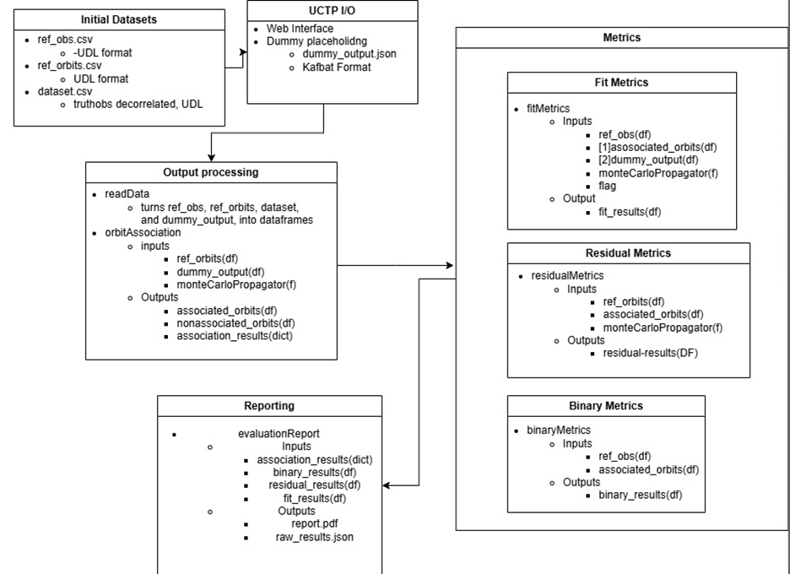

Frame Conversion
unitConversion

Orbit Association

Propagation

monteCarloPropagator

ephemerisPropagator

TLEpropagator

State Metrics

Residual Metrics
residualMetrics has the following input arguments:
- ref_obs (Pandas Dataframe) : dataframe containing the list of reference observations
- mode_df (Pandas Dataframe) :
(a) associated_orbits : dataframe containing lists of observations actually relevant to specific states
(b) uctp_outputs : dataframe containing lists of observations deemed relevant to specific states by the UCTP
- propFunc (Python Function) : function containing the propagator to be used
- flag (Boolean) :
(a) True : represents use of associated_orbits dataframe
(b) False : represents use of uctp_outputs dataframe
Note that (a) and (b) represent separate calls to the fitMetrics function with differing comparison dataframes as outlined above.
The function utilizes multicore processing to simultaneously propagate states to their respective correlated observations. Beyond this, the function also ensures minimal processing within each set of state residuals by using sequential propagation (chains propagation together by using the last iteration’s propagated state as the new initial state for propagation to the next chronological epoch).
After propagation is complete and residuals are determined, further basic statistical quantities are calculated and used as metrics. The outputs are as follows:
- fit_residuals (Pandas Dataframe) :
– “id” : column of lists containing IDs of the observations that are associated with the state in question
– “Epoch” : column of lists containing the epochs that are associated with each observation
– “Residuals” : column of lists containing the great circle residuals for each state propagation
– “RMSE” : column containing the root mean square of the residuals for each correlated state
– “Mean” : column containing the mean of the residuals for each correlated state
– “std” : column containing the standard deviation of the residuals for each correlated state

Resources that are very useful
https://github.com/AirMettle/HMDH
https://forum.orekit.org/
https://www.orekit.org/site-orekit-11.0/apidocs/overview-summary.html

Binary Classification Metrics
binaryMetrics
Input Arguments
- ref_obs (pd.DataFrame):
Reference Orbit observations. Must contain the following columns:
  - 'id': Unique identifier for each observation.
  - 'satNo': True satellite number associated with the observation.
- associated_orbits (pd.DataFrame):
Result of Orbit Association. Must contain:
  - 'satNo': The predicted satellite number.
  - 'sourcedData': A list or iterable of observation 'id' values associated with the given satellite

Returns
- pd.DataFrame: metrics_dict
A single-row DataFrame containing the following binary classification metrics:
Column | Description
TotalObs | Total number of reference observations.
TotalCorrelated | Number of observations that were successfully associated with a predicted satellite.
TruePositives | Number of correct associations (observation assigned to orbit of same satellite number).
FalsePositives | Number of incorrect associations (observation assigned to orbit of different satellite number).
TrueNegatives | Set to 0 (not computed in this implementation).
FalseNegatives | Number of missed associations (observation not assigned to satellite).
Accuracy | Accuracy of the correlation (TP + TN) / (TP + FP + TN + FN).
BalancedAccuracy | Average of recall for both classes.
CohenKappa | Cohen's Kappa statistic for inter-rater agreement.
MatthewsCorrCoef | Matthews correlation coefficient, a balanced measure for binary classification.

Louis Caves: louiscaves@gmail.com Binyamin Stivi: binyamin.stivi@gmail.com Gabriel Lundin: glundin76@gmail.com Miles Puchner: milespuchner@gmail.com

